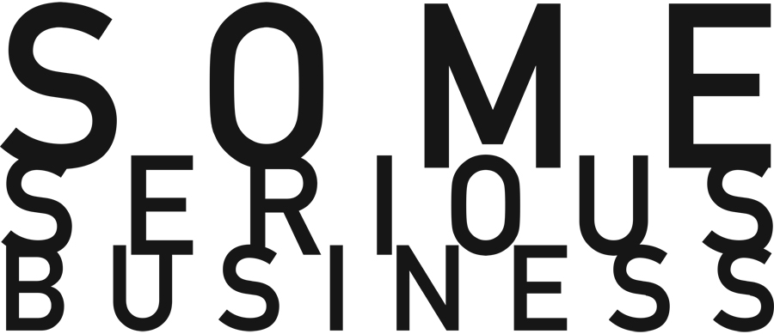

SSB PRESENTS “The most dangerous poet in America” —The Observer (UK)

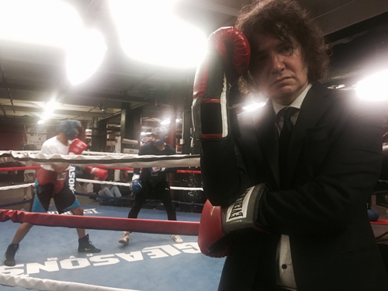

Mike Tyler
BLACK NIGHT, BLACK KNIGHT
Performance and Publication Party
Saturday, April 30th / 7 PM / Free
Gleason’s Gym, 77 Front St, Brooklyn, NY 11201
For further information visit someseriousbusiness.org. #BlackNightBlackKnight

Poets were rock stars. It was the 90’s and they touched the live nerve of popular culture. Not since the Beats banged their bongos had this proudly obscure art form practiced by teenage girls and goggled academics hit out like the super swing of a juiced-up baller into the stratosphere of a larger audience. At the center of this movement was Mike Tyler, a poet who wanted to bridge the gap between his heroes—Walt Whitman, Wallace Stevens and William Carlos Williams—and the direct, jagged, jaw-displacing punk rock rebellion of the music and performances he loved.

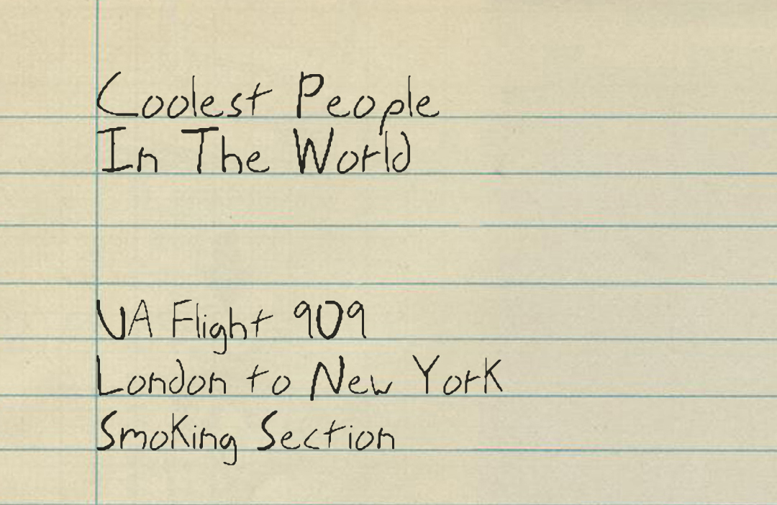

In his new book, Black Night, Black Knight, Tyler’s poems evoke a time when phone booths still existed, you could smoke on planes, and Richard Nixon had just died—inspiring the shortest poem in the book: “Good.” Infamous for breaking his arm during a particularly tumultuous reading, Tyler’s writing is fueled by a red-hot, molten exchange with his audience and his contemporary hallucinatory and sharp-edged phrasing give a direct experience of a moment in poetic time that The Village Voice says “pulses with the same euphoric heartbeat that made Rimbaud the proto punk rock hero.”

Published by The Art Cannot Be Damaged (TACBD), April 2016.
ISBN #: 978-1-59937-017-0 / 351 pages
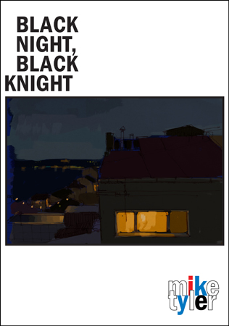

ABOUT SOME SERIOUS BUSINESS
The Artist Always Come First
Founded at the height of the Conceptual 70s, Some Serious Business incubates emergent expression in the arts, germinates intrepid new works and ideas, and presents diverse projects that celebrate audacity, experimentation, and surprise. Our core artist-driven programs and partnerships are both catalysts and sanctuaries that sustain visionary creators and thought-leaders.

Based on the principle that the artist always comes first, SSB supports hybrids and chimeras that traverse performance, literature, theater, dance, visual art, moving image, music, architecture and design, social practice, and fields of unforeseen possibilities.

Guided by eggheads and free spirits who value collaboration, SSB is as much about process as outcomes. From the ridiculous to the sublime, SSB revels in the creative process—embarking with artists and fellow travelers to explore the puzzles, mysteries, messiness, challenges, dialogue, and peak experiences along the way.

X X X X X

For further information contact Some Serious Business
Susan Martin, susan@someseriousbusiness.org / 310 975 9970
Danielle Lesniewski, Danielle@someseriousbusiness.org / 310 428 2325
Norma Kelly, norma@martinmpr.com / 818 395 1342

